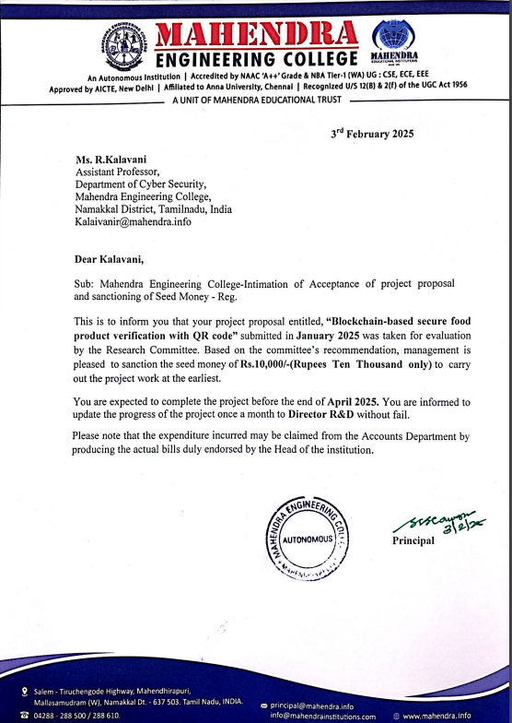

**INNOVATIVE PROJECT REPORT**

**Project Title:** Blockchain-based Secure Food Product Verification with QR Code

**Student:** Praveen A (Reg. No: 6113231281058)

**Project Supervisor:** R Kalaivani, AP – Cyber Security  
**Department:** Cyber Security, Mahendra Engineering College

**Abstract** This is the project called Supply Chain Secure is a blockchain-based product verification system designed to improve transparency, reliability, and trust in supply chains across various industries, including food, agriculture, and consumer goods. Traditional centralized tracking systems are prone to data tampering, human errors, and inefficiencies, which can lead to counterfeiting, product mismanagement, and compromised quality. This project integrates blockchain technology with QR code verification to provide a secure, immutable, and transparent method of tracking products from manufacturers to consumers. Each product is assigned a unique QR code that links to its blockchain record, allowing consumers, retailers, and regulatory authorities to instantly verify essential information such as product origin, production and expiry dates, batch numbers, and storage conditions. In addition to real-time verification, the system incorporates automated notifications for product movements, recalls, or expiration alerts, ensuring timely updates for stakeholders. By combining the decentralized, tamper-proof nature of blockchain with user-friendly QR code verification, this system reduces fraudulent activities, enhances operational efficiency, and builds consumer confidence, thereby optimizing the overall supply chain process.

**Introduction** The global supply chain faces challenges such as counterfeit products, manual record-keeping errors, and lack of transparency. Traditional centralized databases cannot fully prevent manipulation and fraud. Blockchain, with its decentralized, tamper-proof ledger, provides a robust solution for secure product tracking.

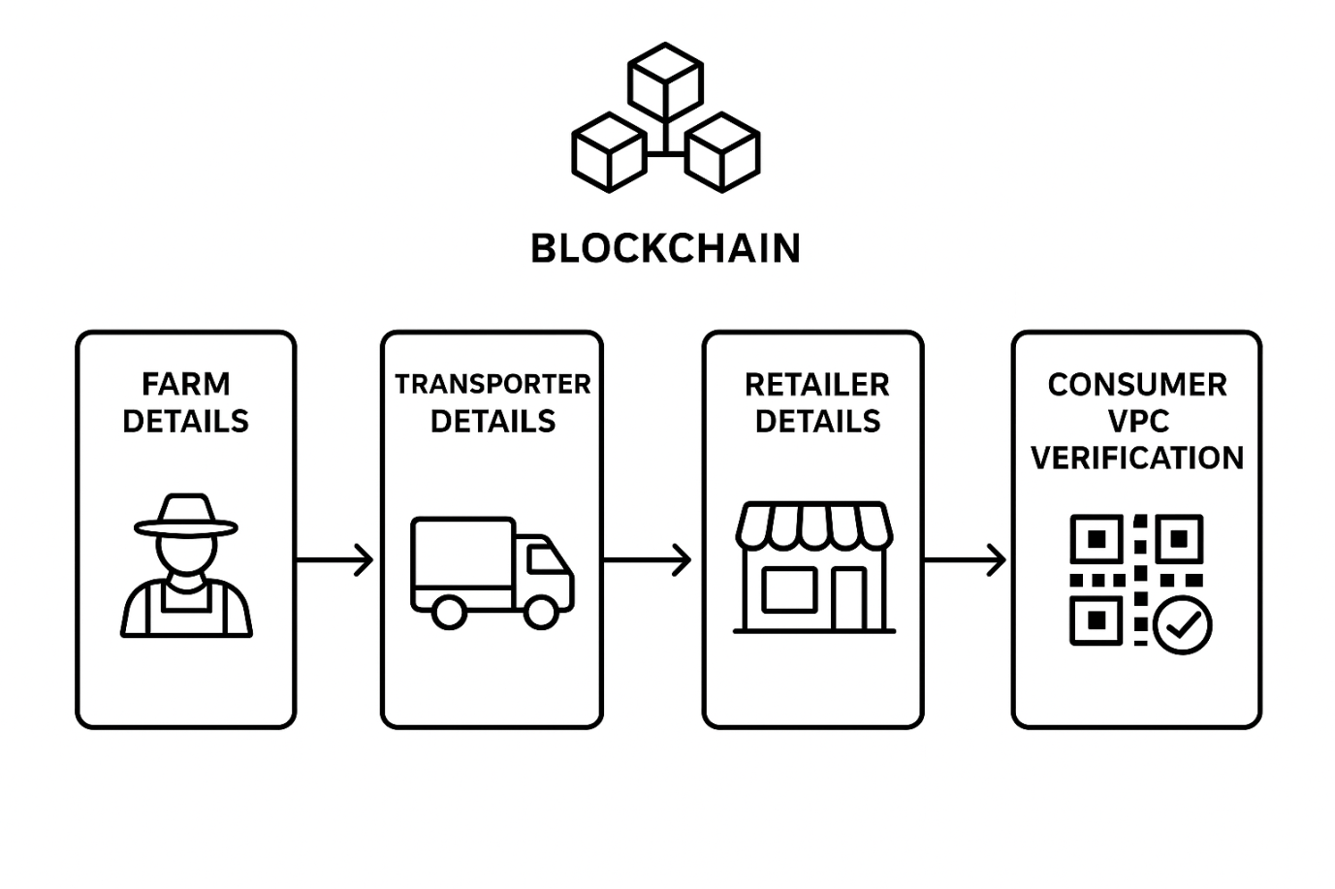

**System Overview of Blockchain-based Product Verification**

**Novelty and Aim of the Work**  
**Novelty**

The system leverages blockchain technology to provide tamper-proof and immutable storage, ensuring that every entry of farm, transporter, and retailer data is securely recorded and cannot be altered.

By using smart contracts, supply chain processes such as validation of product details and transaction verification are automated, thereby minimizing manual intervention and human error.

QR code integration enables consumers to instantly scan and authenticate product details at any point, ensuring transparency and building trust.

The system is further strengthened by IoT sensor integration, which continuously monitors product conditions such as temperature, humidity, and handling during transport, providing real-time data that is also recorded on the blockchain.

This approach not only improves traceability but also enhances consumer confidence and regulatory compliance, setting it apart from conventional supply chains.

**Aim**

The primary aim of the project is to develop a blockchain-enabled supply chain system that ensures:

* Authenticity of products through immutable blockchain records.
* Transparency and traceability by securely recording every stage (farm → transporter → retailer).
* Consumer empowerment by allowing them to verify product details instantly using QR code scanning.
* Improved quality assurance by integrating IoT-based monitoring for product conditions, ensuring safer and more reliable delivery from farm to consumer.

**Materials and Methods**

| Item | Quantity | Purpose |
| --- | --- | --- |
| DHT22 Temperature Sensor | 1 | Monitors storage conditions |
| RFID Module (MFRC522 + Tags) | 1 | Automated record entry |
| ESP32 Board (Wi-Fi + Bluetooth) | 1 | Central hub for IoT data |
| QR Code Printer & Labels | 1 | Prints product-specific QR codes |
| Power Supply & Miscellaneous | - | Ensures reliable operation |

**Hardware Setup of the Project:**

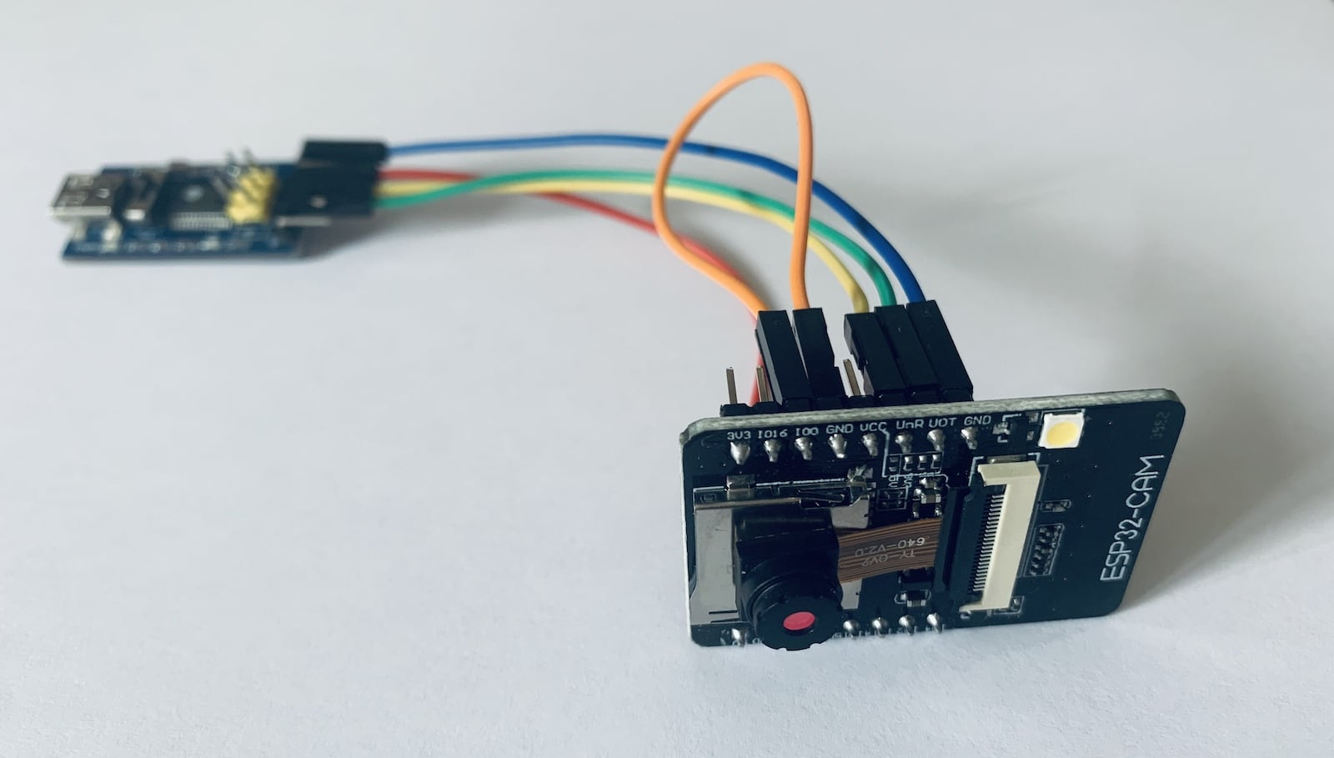

The ESP32-CAM

**Uses of ESP32-CAM in This Project:**

The ESP32-CAM plays a central role in the farm-to-fork blockchain-based supply chain system by enabling automation, product validation, and secure data recording. Its integration ensures that only genuine and verified products enter the blockchain for traceability and consumer authentication.

1. Object Detection (Product Recognition)

* The ESP32-CAM is equipped with a built-in camera that can capture real-time images of the product (e.g., watermelon, vegetables, or packaged food items).
* When a product is placed in front of the ESP32-CAM, it performs basic object detection to confirm the presence and type of the product.
* This acts as a verification step before any data is recorded in the blockchain, ensuring that only valid items are registered.

2. Automated Data Entry to Blockchain

* Once a product is detected, the ESP32-CAM triggers automatic data entry into the blockchain.
* Details such as farm information, harvest date, transporter ID, and retailer entry are linked to the product.
* This eliminates the need for manual human input, reducing the risk of errors and fraud in the supply chain.

3. QR Code Generation Trigger

* After product recognition and blockchain entry, the ESP32-CAM can send a signalto the QR code printer.
* The printer generates a unique QR code that represents the verified blockchain record of the product.
* This QR code is later pasted or tagged onto the product, enabling end-to-end traceability and consumer verification.

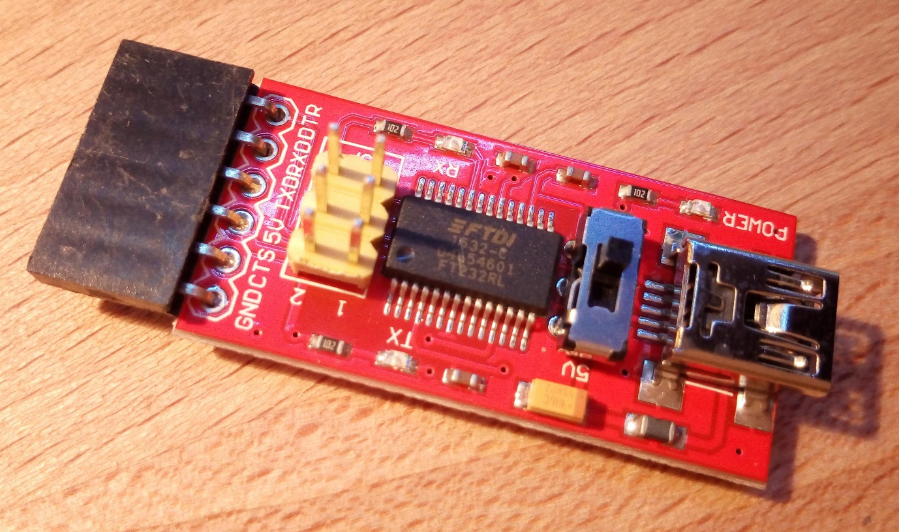

**FTDI Programmer**

**Role of the FTDI Programmer**

The **FTDI programmer** is essential for programming and flashing code onto the ESP32-CAM module. Since the ESP32-CAM does not come with a built-in USB interface, the FTDI programmer is used as a **USB-to-Serial adapter**.

**Functions of FTDI Programmer in This Project**

1. **Uploading Code**
   * It allows developers to upload custom firmware and image detection algorithms onto the ESP32-CAM.
2. **Serial Communication**
   * Provides a communication bridge between the ESP32-CAM and the computer for debugging and monitoring real-time data.
3. **Power Supply During Programming**
   * Supplies 5V/3.3V power to the ESP32-CAM during code flashing.

.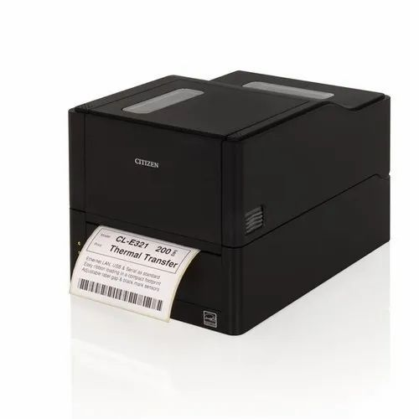

**QR Coder label printer**

**Uses of QR Codes in This Project**

* Product Authentication for Consumers
* Each product is tagged with a unique QR code generated after registration by the farmer, transporter, and retailer.
* When a consumer scans the QR code using a mobile phone, they instantly receive details such as product origin, harvest date, transport history, and arrival details at the retailer.
* This prevents counterfeit or duplicate product data, ensuring authenticity.
* Traceability Across the Supply Chain
* The QR code links the product to its complete journey in the supply chain.
* At each stage (farm → transport → retail), new data is added and associated with the same QR code.
* This makes it easy to trace the product back to its source in case of food safety checks or quality concerns.
* **Easy Access to Data**
* Instead of manually checking databases, consumers, suppliers, and regulators can simply scan the QR code to fetch real-time data.
* This saves time and provides convenience since mobile scanning apps are widely available.
* Integration with Blockchain
* The QR code acts as a key to access blockchain-stored data.
* Since blockchain ensures data immutability, scanning the QR code gives tamper-proof and transparent product details.
* Regulatory and Certification Compliance
* Food safety regulators (e.g., FSSAI in India) can scan QR codes to verify compliance with manufacturing, packaging, and expiry standards.
* Helps streamline inspections and reduces paperwork.
* Building Consumer Trust
* By scanning the QR code, consumers gain confidence that the product is genuine, safe, and traceable.

**Software / Tech Stack**

* Blockchain (gun Db)
* Web3.js, HTML, CSS, JavaScript
* Python for QR code generation
* IPFS for decentralized storage

**Methodology**

* IoT sensors collect product data (temperature, RFID scans).
* Data stored on blockchain for immutability.
* Generate QR codes linking to blockchain records.
* Frontend UI allows consumers to verify products.
* Smart contracts automate alerts for recalls, expiry, or shipment updates.

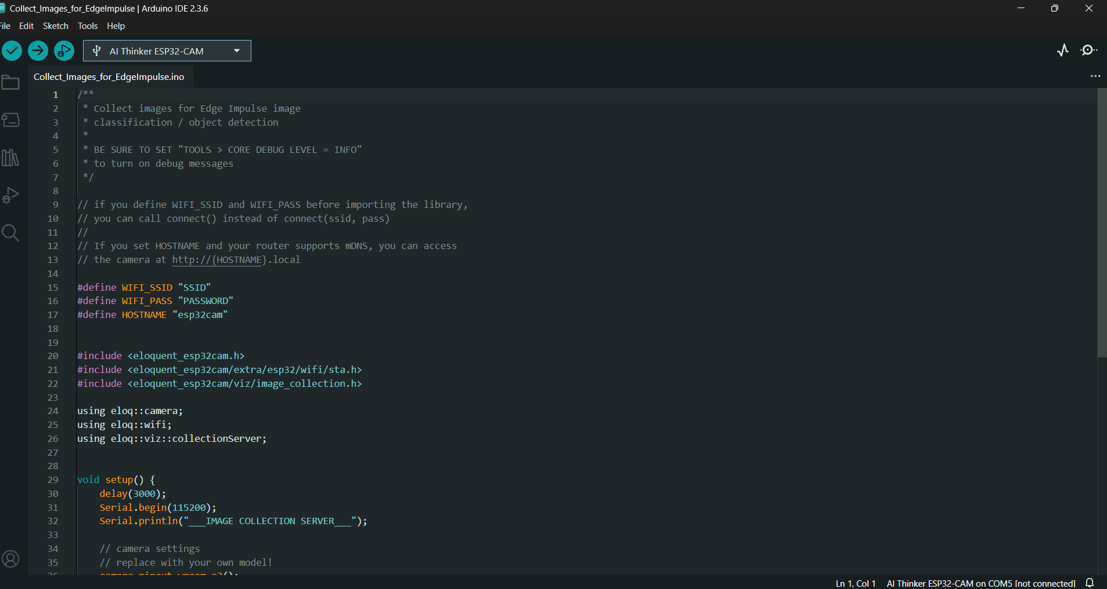

**Arduino IDE**

**Purpose of the Code**

This sketch (Collect_Images_for_EdgeImpulse.in) is used to collect images from the ESP32-CAM and send them to a server (like Edge Impulse or a local collection server). It is mainly for object detection / classification training.

In your project, the goal is to detect the product (e.g., fruit, food package, etc.) and verify it before recording on the blockchain. For this, the ESP32-CAM first needs to capture and classify product images. This code enables that process.

Wi-Fi Connectivity Setup

* The code defines WIFI_SSID and WIFI_PASS so the ESP32-CAM can connect to your local Wi-Fi network.
* This allows image data to be uploaded wirelessly to a server or dataset collector.

Camera Initialization

* Using the eloquent_esp32cam library, the ESP32-CAM is initialized to capture images.
* You can set the resolution, brightness, and other settings for product recognition.

Image Collection for Training Dataset

* The ESP32-CAM captures multiple images of products (like fruits, packaged food, etc.) and stores/sends them to a collection server.
* These images are later used to train a machine learning (ML) model for object recognition.

Integration with Edge Impulse / ML Models

* The code allows integration with Edge Impulse (a popular embedded ML platform).
* You can train models (e.g., “Is this watermelon or not?”) and later deploy them back to the ESP32-CAM.

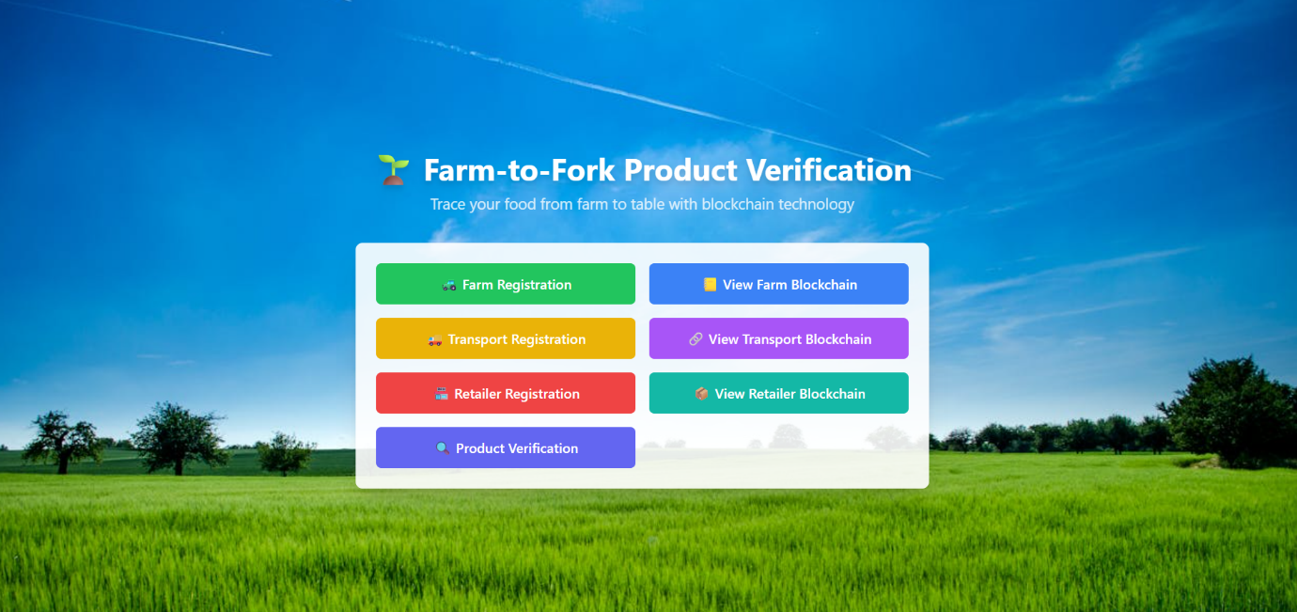

**Web Page Interface**

**Web Page Interface Explanation**

The above figure shows the web-based interface of the Farm-to-Fork Product Verification System, which is designed to provide a user-friendly platform for managing supply chain data and verifying products through blockchain technology.

The interface consists of different modules:

* Farm Registration – Farmers can register their products by entering details such as crop type, harvest date, and farm location. These details are securely stored on the blockchain.
* Transport Registration – Transporters record shipment details including vehicle information, transport date, and storage conditions during transit.
* Retailer Registration – Retailers update information about product arrival, shelf placement, and sales availability.
* Product Verification – Consumers can scan the QR code attached to the product and instantly verify its authenticity, origin, and complete journey through the blockchain.

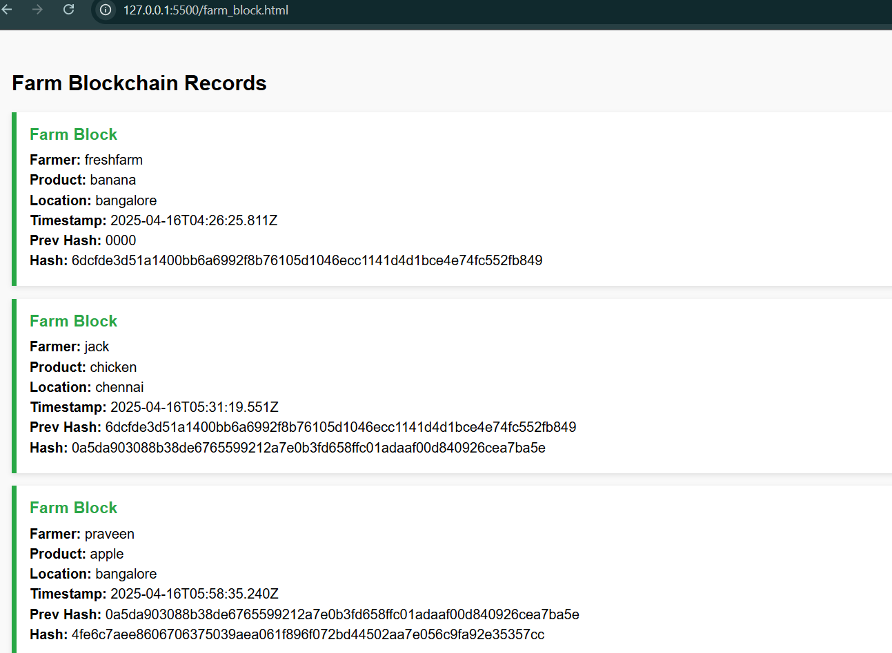

**Farm Blockchain Record**

**Explanation of Farm Blockchain Data**

The figure displays the farm blockchain records, where each entry represents a block containing details of a registered product. Every block securely stores farm information, product details, timestamps, and cryptographic hash values to ensure immutability.

Each Farm Block includes:

* Farmer Name – Identifies the farmer who registered the product (e.g., fresh farm, jack, Praveen).
* Product – Specifies the type of product (e.g., banana, chicken, apple).
* Location – Shows the farm location (e.g., Bangalore, Chennai).
* Timestamp – Records the exact date and time of registration, ensuring transparency.
* Prev Hash (Previous Hash) – Links the block to the previous one, creating a secure blockchain chain.
* Hash – Unique cryptographic code generated for the block, ensuring that data cannot be altered.

This structure guarantees traceability, authenticity, and security of farm data. Once a product is registered, the information becomes immutable, meaning no stakeholder can modify it. This makes the supply chain tamper-proof and ensures consumers get trustworthy product information.

**Result and Discussion**

The Farm-to-Fork Blockchain-based Product Verification System successfully demonstrates how food products can be securely traced throughout the supply chain, ensuring trust, traceability, and transparency for both consumers and regulatory bodies like FSSAI. By leveraging blockchain technology and QR code integration, the system provides a robust framework for tracking food products from their origin at the farm to the consumer's hands, addressing critical challenges in the food industry.

This project resolves the major challenges of today’s food industry, such as counterfeit food products, lack of consumer trust, and absence of transparent supply chain records, by using a blockchain-inspired model combined with QR code technology. The decentralized and immutable nature of blockchain ensures that data entered at each stage is tamper-proof, while QR codes provide an accessible interface for consumers to verify product authenticity. The system is designed to be scalable, cost-effective, and compliant with regulatory standards, making it a practical solution for widespread adoption.

**Step 1: Product Arriving from Farm**

* The process begins when a food product (e.g., fruits, vegetables, or grains) is harvested at the farm.
* The farmer or the automated IoT device records essential details such as:
  + Product Name: Identifies the specific crop or product (e.g., organic tomatoes, basmati rice).
  + Harvest Date: Records the exact date of harvest to ensure freshness tracking.
  + Farm Location: Captures the geographical origin (e.g., GPS coordinates or farm address) for traceability.
* This information is the first block in the blockchain chain, establishing the foundation for the product’s journey.

**Detailed Explanation**:  
At the farm, data collection can be manual (entered by the farmer via a mobile app) or automated using IoT devices like the ESP32-CAM, which captures images of the harvested product and timestamps them. The first block is created using a blockchain framework (e.g., a lightweight version of Ethereum or Hyperledger adapted for IoT). The block includes a unique identifier for the product batch and is cryptographically signed to prevent tampering. This ensures that the origin data is authentic and verifiable by all subsequent stakeholders. For example, a batch of mangoes from a farm in Maharashtra would have its harvest details (e.g., "Alphonso Mango, harvested: 02-Sep-2025, Location: Ratnagiri") recorded as the genesis block.

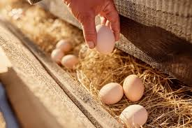

A diagram of a farm with product harvesting → first block created.

**Step 2: Verifying the Product using Blockchain**

* Once the farm block is created, the system automatically generates a **hash value** for the block.
* Each new block contains:
  + **Product Name**: Consistent identification of the product across the chain.
  + **Date and Time** of entry: Timestamp for when the block is added.
  + **Hash**: A unique digital fingerprint generated using a cryptographic algorithm (e.g., SHA-256).
  + **Previous Hash**: A reference to the hash of the previous block, linking them in a chain.
* This ensures **immutability** – no one can alter the product data once entered.
* An ESP32-CAM or similar IoT device can automatically capture **product images**, and record date and time without manual entry.

**Detailed Explanation**:  
The blockchain’s immutability is achieved through cryptographic hashing, where each block’s hash is a function of its data and the previous block’s hash. For instance, if the farm block’s data is altered (e.g., changing the harvest date), the hash would no longer match, breaking the chain and alerting stakeholders. The ESP32-CAM plays a critical role here by capturing high-resolution images of the product (e.g., a crate of tomatoes) and embedding metadata like timestamp and GPS coordinates. These images are stored off-chain (e.g., in a cloud database like IPFS) with their hash linked to the blockchain, ensuring data integrity without overloading the chain with large files. This step verifies the product’s authenticity at the source, critical for preventing counterfeit goods from entering the supply chain.

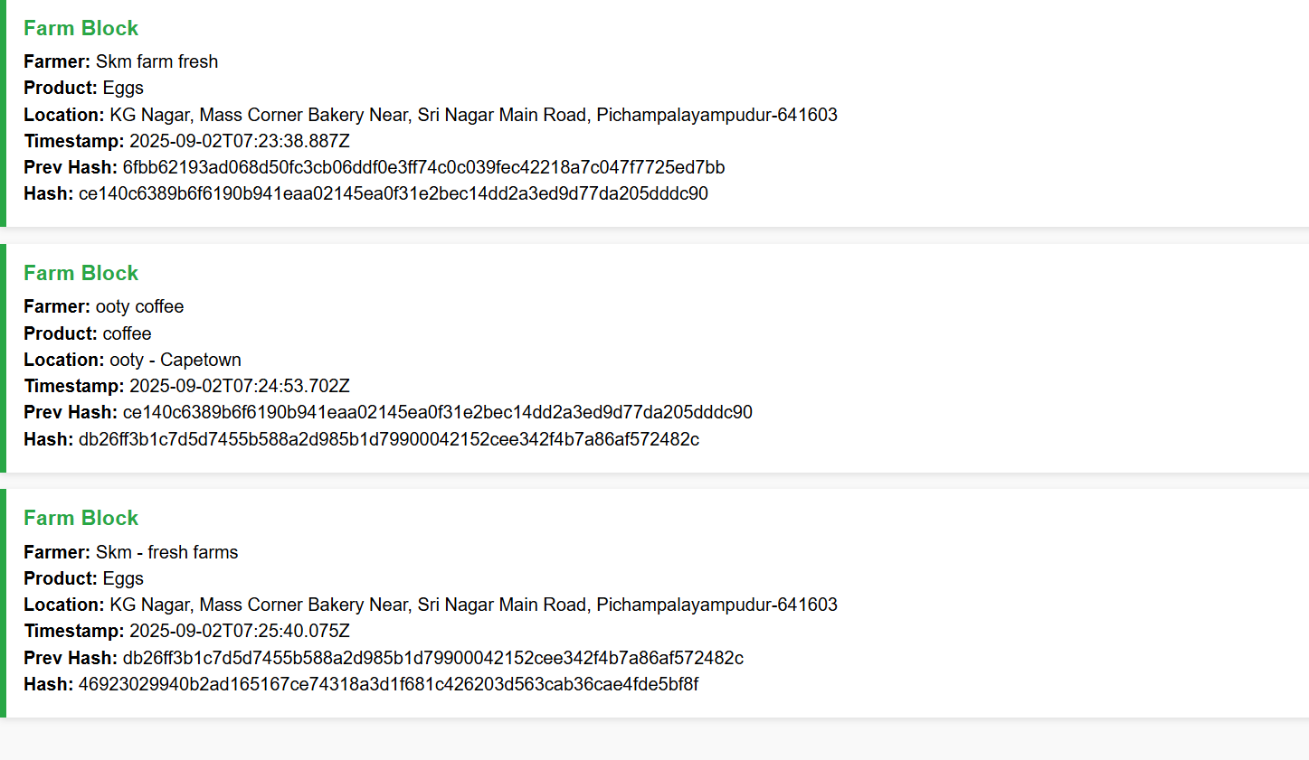

A blockchain diagram showing product block with hash and previous hash.

**Step 3: Registering Farm, Transport, and Retailer Details**

* After product verification, supply chain details are registered in three stages:
  1. **Farm Details:** Farmer name, farm location, harvest date, crop/product type.
  2. **Transport Details:** Vehicle number, dispatch date, arrival date, mode of transport.
  3. **Retailer Details:** Retailer/shop name, batch ID, arrival date at shop, best-before date.
* Each registration step creates a new block in the blockchain with its **hash and previous hash**, ensuring continuity and authenticity.

**Detailed Explanation**:

Each stage in the supply chain adds a new block, creating a continuous, tamper-proof record. For example:

* **Farm Block**: "Farmer: Rajesh Patel, Location: Nashik, Harvest Date: 02-Sep-2025, Crop: Grapes."
* **Transport Block**: "Vehicle: MH-04-XY-1234, Dispatch: 03-Sep-2025, Arrival: 04-Sep-2025, Mode: Refrigerated Truck."
* **Retailer Block**: "Retailer: Fresh Mart, Batch ID: GRP-0925-001, Arrival: 04-Sep-2025, Best Before: 10-Sep-2025." Each block is linked via the previous hash, ensuring that any tampering (e.g., altering transport dates) would invalidate the chain. IoT devices like the ESP32-CAM can automate data capture during transport (e.g., scanning crates at dispatch) and at retail (e.g., logging arrival). This multi-stage registration ensures full traceability, allowing regulators like FSSAI to audit the supply chain and verify compliance with safety standards.

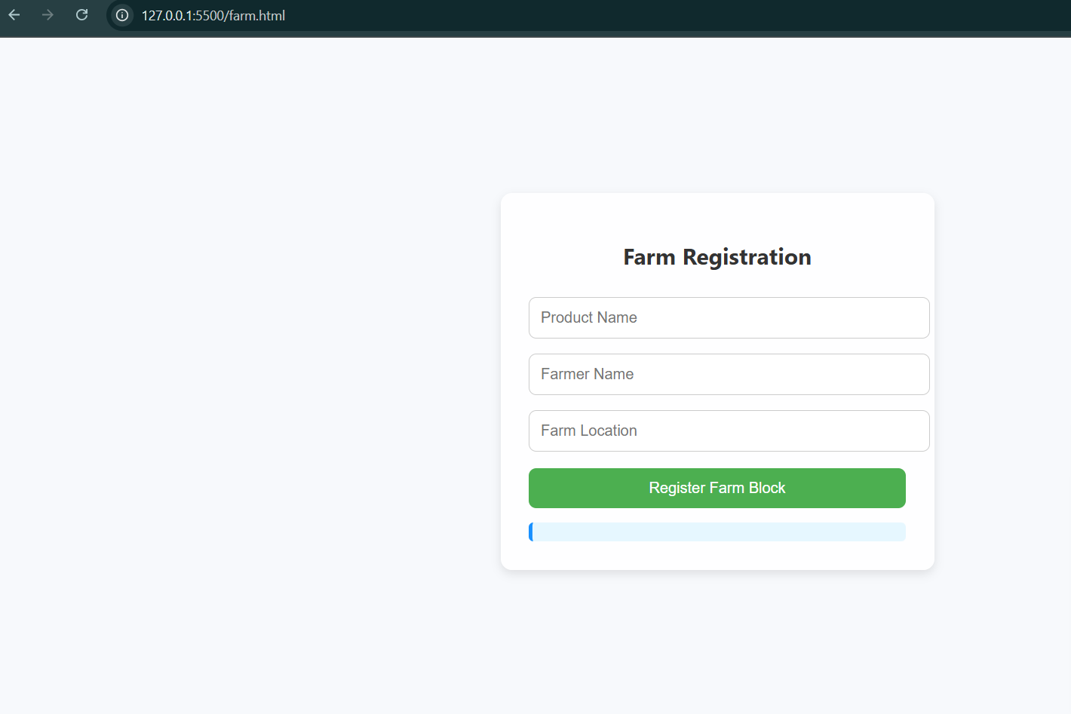

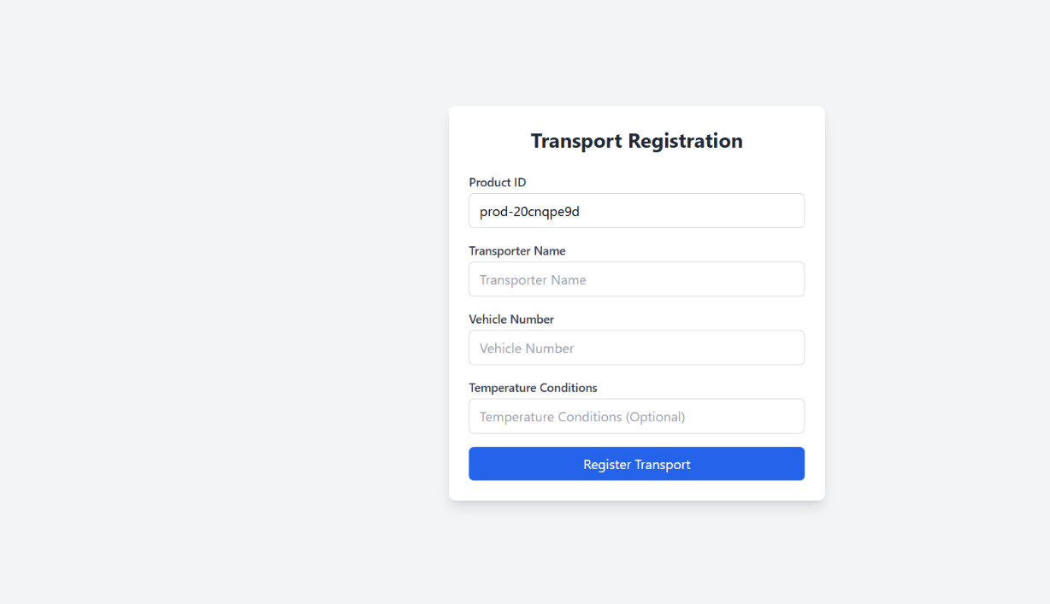

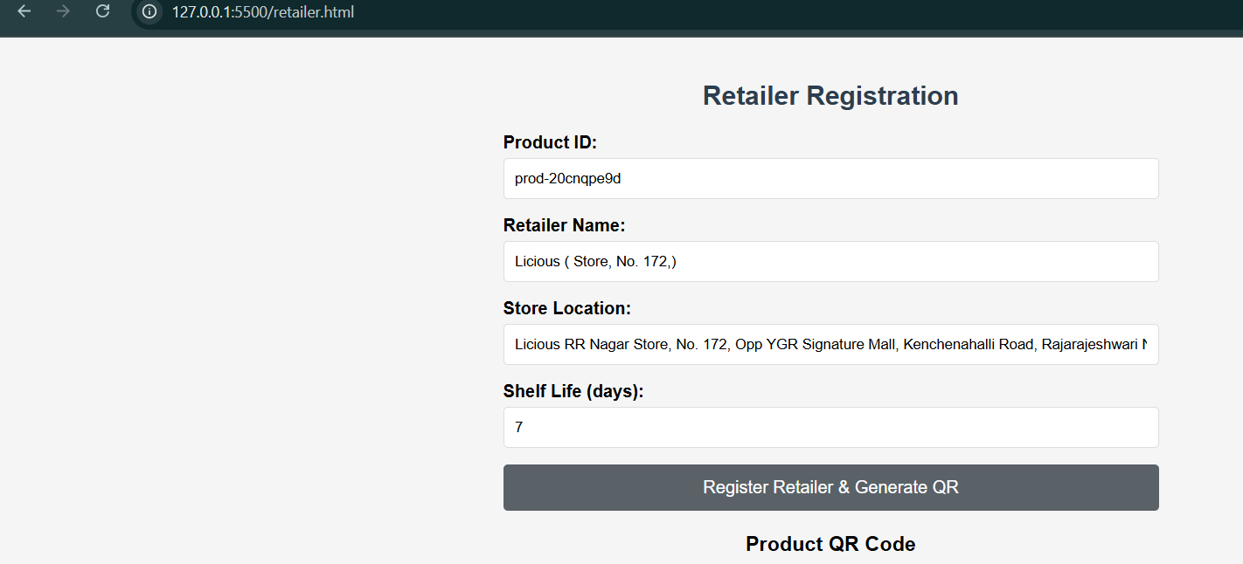

**Step 4: Generating the Final QR Code**

* After all, three details (Farm, Transport, Retailer) are successfully recorded, the system generates a **final QR code**.
* This QR code contains only the **essential consumer-facing information** such as:
  + Farmer Name & Location
  + Harvest/Manufacture Date
  + Transport ID and Dates
  + Retailer Name, Batch ID, Best Before Date

**Detailed Explanation**:  
The QR code is generated using a library like QRCode (for Arduino/ESP32) or a server-side tool (e.g., Python’s qrcode library). The QR code encodes a URL or JSON payload linking to a consumer-friendly interface (e.g., a web page hosted on a cloud server) that displays the blockchain-verified details. For example, scanning the QR code on a grape package might show: "Farmer: Rajesh Patel, Nashik; Harvested: 02-Sep-2025; Transported: 03-04 Sep 2025, Vehicle MH-04-XY-1234; Retailer: Fresh Mart, Batch GRP-0925-001, Best Before: 10-Sep-2025." The QR code is compact (storing only a URL or minimal data) to ensure compatibility with standard scanners, while the blockchain backend ensures the data’s authenticity. This step bridges the technical blockchain system with practical consumer access.

sx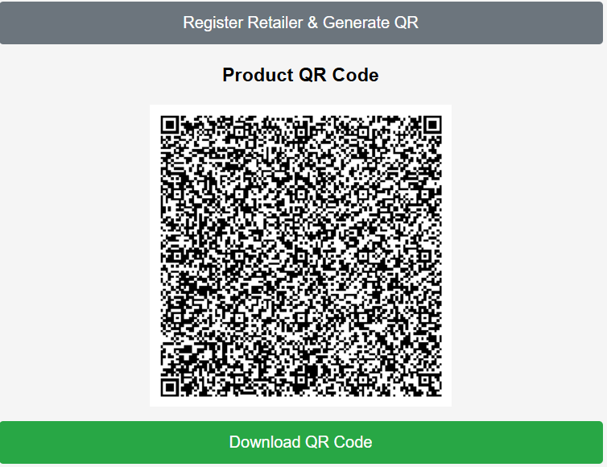  
 QR code being generated from blockchain data.

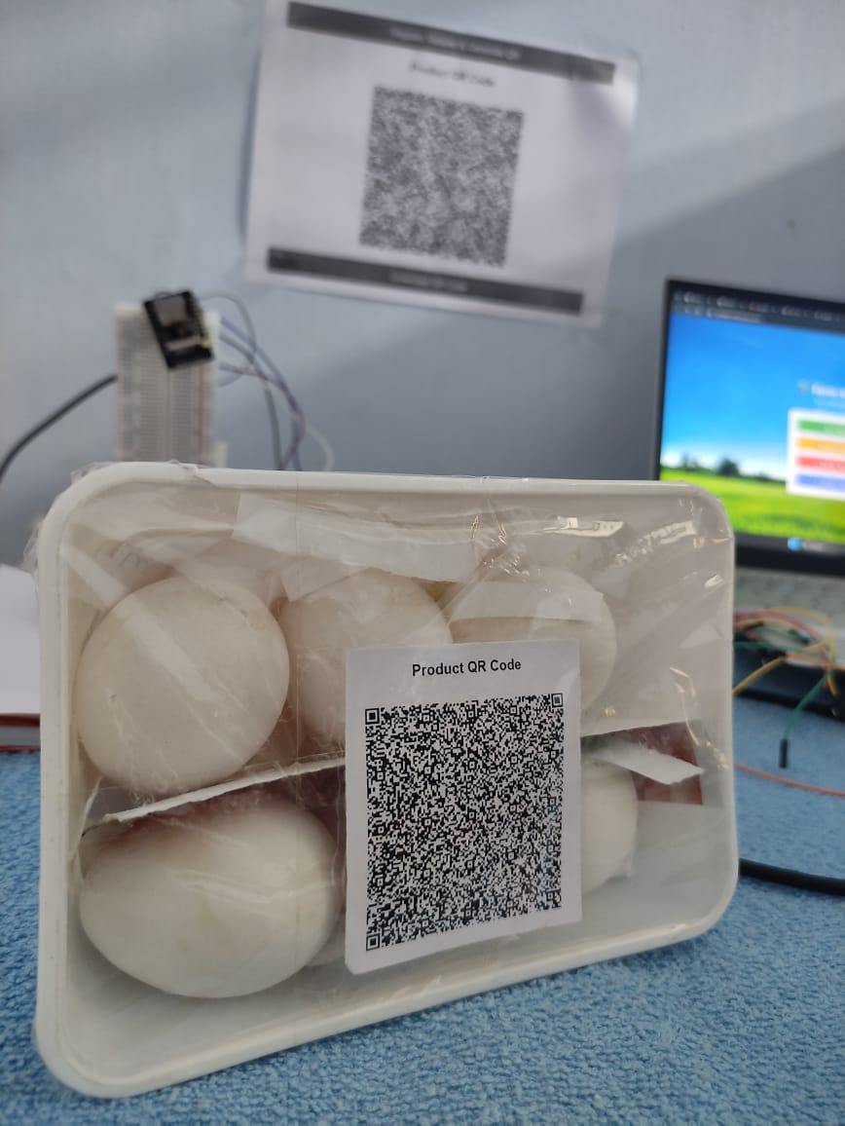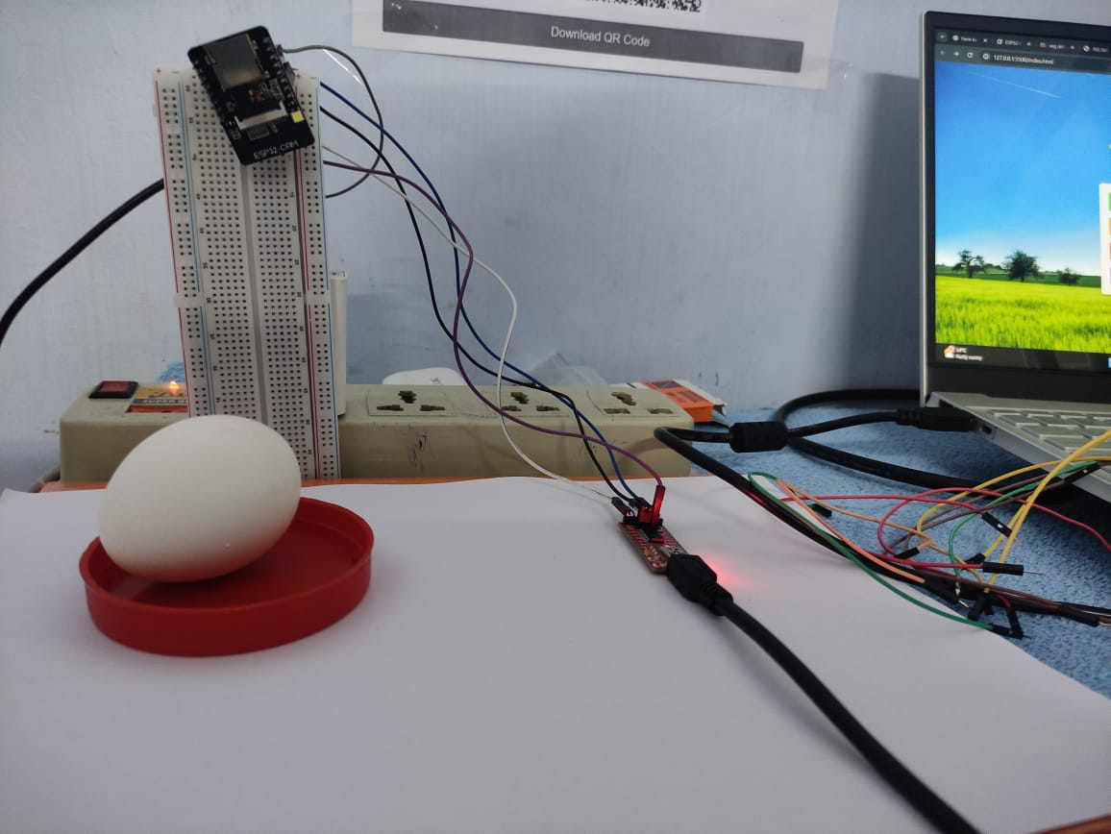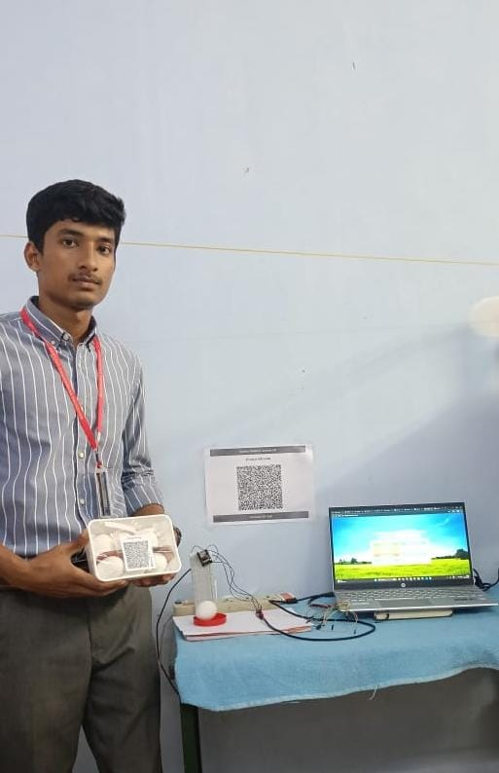

**Discussion**

The results clearly show that this system provides a **robust solution** to current food industry challenges:

* ✅ **Trust**: Consumers gain confidence by verifying farm-to-fork details directly. The blockchain’s immutability ensures that the data presented via QR codes is authentic, fostering trust in the product’s quality and origin.
* ✅ **Traceability**: Every stage (Farm → Transport → Retailer) is recorded in an unalterable blockchain chain. This allows stakeholders, including regulators, to trace a product’s journey back to its source, ensuring compliance with safety and quality standards.
* ✅ **Transparency**: All essential information is open and consumer-friendly through QR codes. The system democratizes access to supply chain data, making it easy for consumers to understand the product’s history.
* ✅ **Anti-Counterfeit**: Fake or tampered products are easily detectable since blockchain prevents data manipulation. Any attempt to forge a QR code or alter

blockchain data would result in a hash mismatch, alerting consumers and authorities.

Thus, the **Farm-to-Fork Blockchain and QR-based System** is a scalable and effective solution that aligns with **FSSAI’s goal of safe, authentic, and traceable food products** in the Indian market. The use of IoT devices like the ESP32-CAM for automated data capture, combined with blockchain’s security and QR codes’ accessibility, makes this system practical for both small-scale farmers and large retailers. Future enhancements could include real-time temperature monitoring during transport (using IoT sensors) and integration with FSSAI’s database for automated compliance checks.

**References**

1. Nakamoto, S. (2008). *Bitcoin: A Peer-to-Peer Electronic Cash System.*
2. Christidis, K., & Devetsikiotis, M. (2016). *Blockchains and Smart Contracts for the Internet of Things.* IEEE Access.
3. Zheng, Z., Xie, S., Dai, H., Chen, X., & Wang, H. (2017). *An Overview of Blockchain Technology: Architecture, Consensus, and Future Trends.*
4. Wood, G. (2014). *Ethereum: A Secure Decentralised Generalised Transaction Ledger.*
5. Kshetri, N. (2018). *Blockchain’s Roles in Meeting Key Supply Chain Management Objectives.* International Journal of Information Management.

